Section 2: Data gotten are representative after correcting mistakes.
Parameter 1: R². The coefficient of determination (R²) is used to judge the fitting degree of regression equation. For individual, we have:
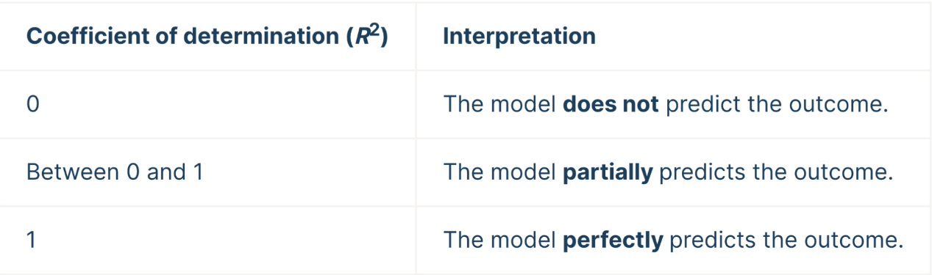
Figure 1. interpreting the coefficient of determination [1]
Most groups` R² is higher than 0.96. But for P8 and M11, R² is particularly low. Besides, R² of M38 Group is lower than 0.9, which means the 3 groups must exist serious mistakes or errors.
Parameter 2: Standard deviation (SD) & Standard Error (SE) . SD reflects how discrete a data set is. Two sets of data with the same mean may not have the same standard deviation. The curve with the lowest standard deviation has a higher peak and a smaller point spread, while the curve with the highest standard deviation is flatter and wider.
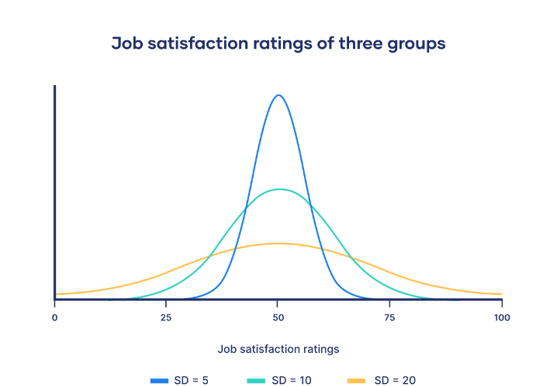
Figure 2. a curve of 3 groups with different SD [2].
The standard error of the mean indicates the degree to which the population mean differs from the sample mean. It tells you how much the sample mean would change if you were to repeat the study using new samples from a single population. Overall, SD describes variability of single sample, and SE estimates variability of multiple samples.

Section 8: Conclusion.
In the course of experimental class, group cooperation always runs through the whole situation. In the process of group cooperation, we find problems, discuss problems and solve problems. Everyone expresses their opinion in the process of cooperation, and progress in the process, and finally understand.

Reference:
[1] Turney, S. (2022, September 14). Coefficient of determination (R²): Calculation &amp; interpretation. Scribbr. Retrieved March 4, 2023, from https://www.scribbr.com/statistics/coefficient-of-determination/
[2] Bhandari, P. (2023, January 20). How to calculate standard deviation (guide): Calculator &amp; examples. Scribbr. Retrieved March 4, 2023, from https://www.scribbr.com/statistics/standard-deviation/

